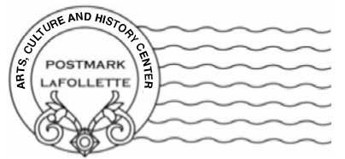www.postmarklafollette.weebly.com | POSTMARK LaFOLLETTE
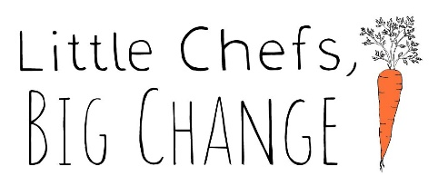

FREE YOUTH COOKING CAMP – LITTLE CHEFS BIG CHANGE

REGISTRATION FORM – COOKING CAMP – STARTS JUNE 12 ENDS JUNE 24 6 week sessions, Maximum 12 Students, target ages 9+

(NO class July 3rd) ALL CLASSES ARE FROM 1 – 3 pm on Wednesday
LOCATION: 119 S. TENNESSEE AVENUE – EMAIL QUESTIONS TO postmarkartcamp@gmail.com, Julie Van Arsdale, Camp Program Director, Application due May 31,2024

Registration Information
Full Name*: |  |  |  | Date:
 | Last | First | M.I.

Address*
 | Street Address | Apartment/Unit #

 | City |  |  | State | ZIP Code
Phone* |  | Email | *
*REQUIRED INFORMATION
E M E R G E N C Y CONTACT* |  | NAME: CONTACT NUMBER:
,
Registration forms can be emailed to: postmarkartcamp@gmail.com
OR
Drop OR mail to Postmark LaFollette 119 S. Tennessee Avenue 37766 attention: Julie Van Arsdale/Cooking Camp

EDUCATION
School: |  |  |  | Age
COMMENTS:
Signature/Parent/Guardian |  |  |  |  |  |  | Date:
. |  | Parents and/or guardians of youth who do not drive are responsible for getting the child to and from the sessions
Our Sponsors |  | and

